Experiential Learning Application 5-Chapter 7
Name
Institutional Affiliation

Experiential Learning Application 5-Chapter 7
Introduction and problem statement
The use of patient-reported information has been appreciated by scholars and practitioners alike as an important measure for capturing subjective opinions that can be used to optimize healthcare delivery (Jepsen et al, 2014). Self-reported health is one of the most important measures of health (Ahmed et al, 2012). Lack of proper health information has been noted as a leading cause of misdiagnosis and improper healthcare planning. It’s important for health assessment to be done on the basis of patient reported data. Self-reported data can therefore be used as a conceptual framework for predicting mortality and such like parameters within a given population.
In this paper, the SEMMA methodology was used to sample, explore, modify, model as well as assess a dataset on self-reported general health. The status of self-reported general health of various individual was predicted on the basis of a number of variables.
Sample
The sample used in the analysis was imported into SAS E-miner using the file import node shown below;
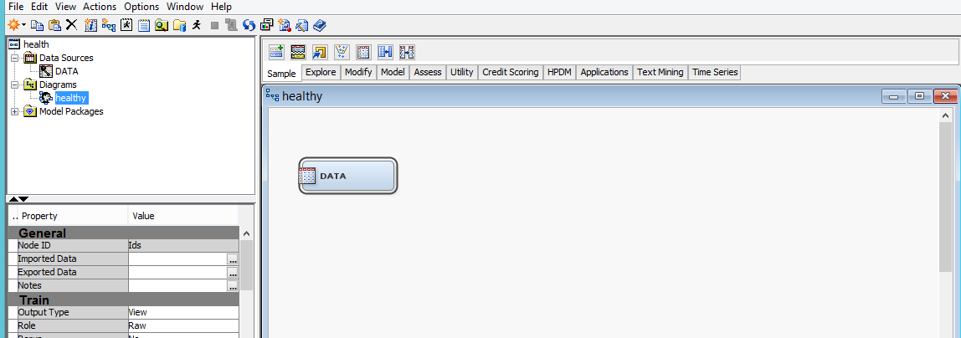
The result of the file import analysis was as follows;
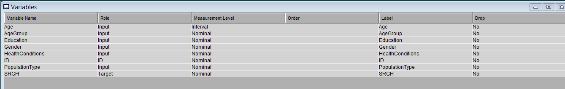
Data portioning was then done using the following process.
Data partition
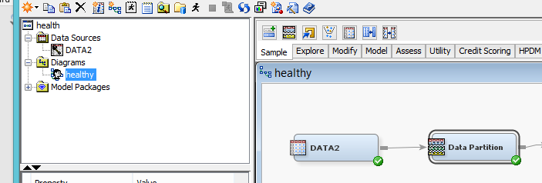
The result of the data partition process is shown below;
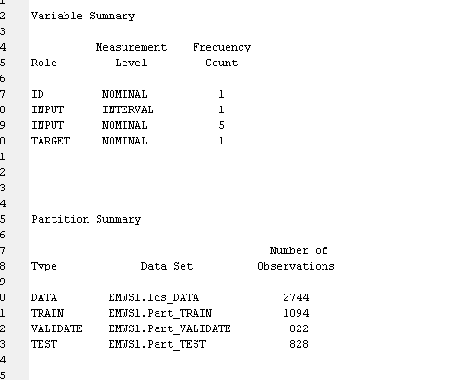

Explore
The explore process is the second is the SEMMA data mining process in SAS Enterprise Miner. During this process. The stat explore, graph explore and multiplot nodes were added to the diagram shown below and then the data stream executed through it. The summary, descriptive statistics, missing data and outliers were found as follows;
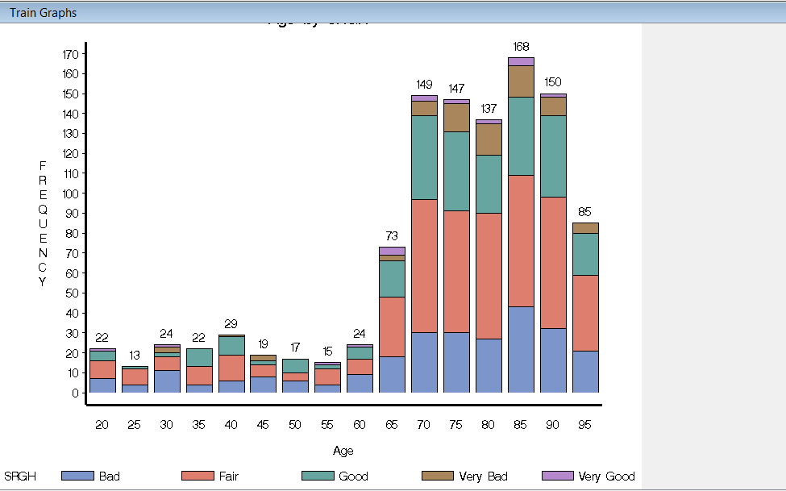
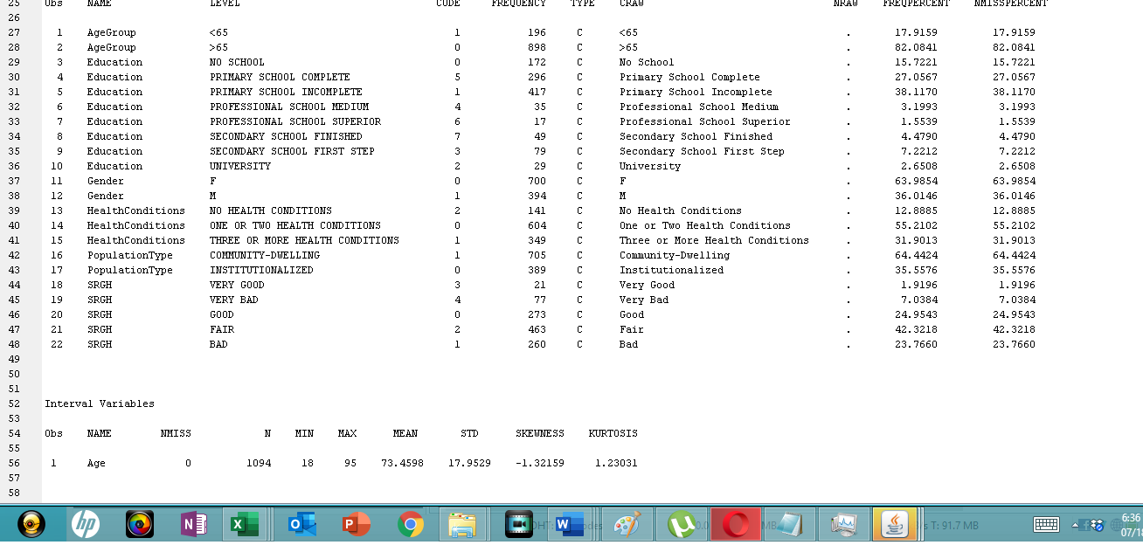
Modify
The modify step is the third step in the SEMMA data mining process. During the process the impute node was used to impute the dataset. The imputation stage was necessary to estimate al missing values using a special estimation algorithm. The result of the data imputation process was found as follows;

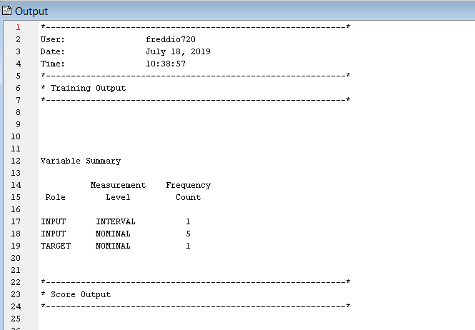

Model
Modeling is the fourth and most important step in the data analysis process. In this case, the decision tree node was used to process the data. The full model diagram is shown below;
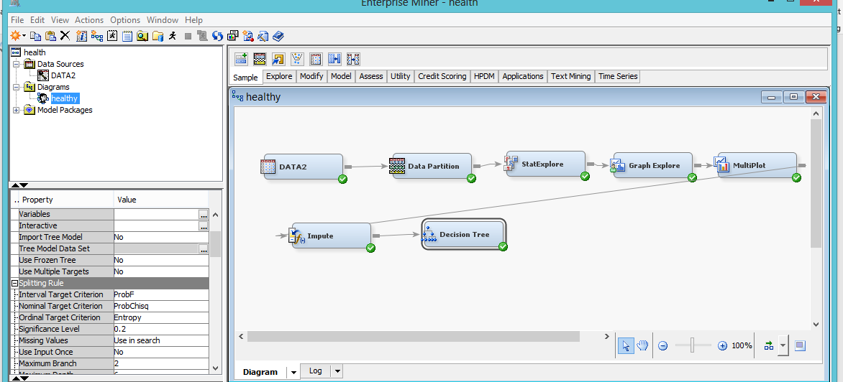
The result of the analysis yielded the following decision tree model outcome
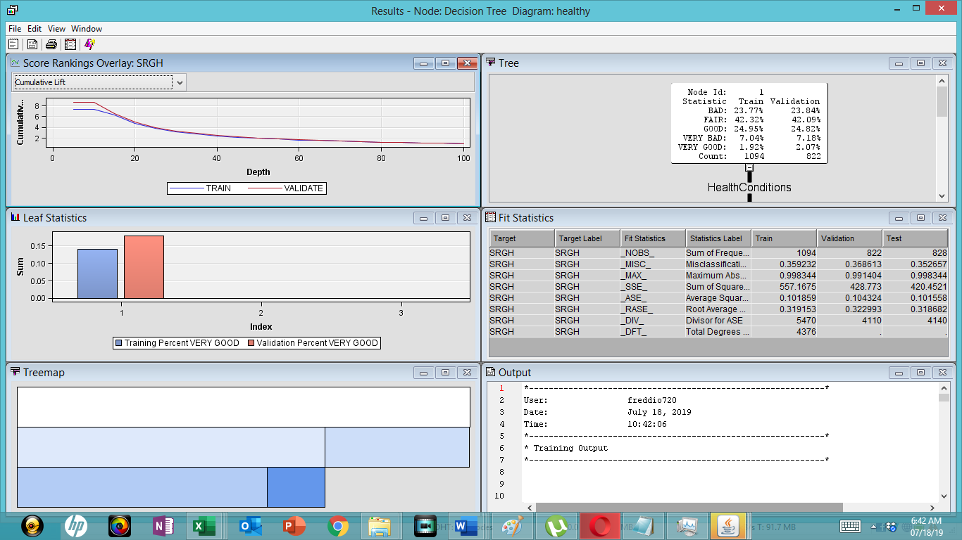

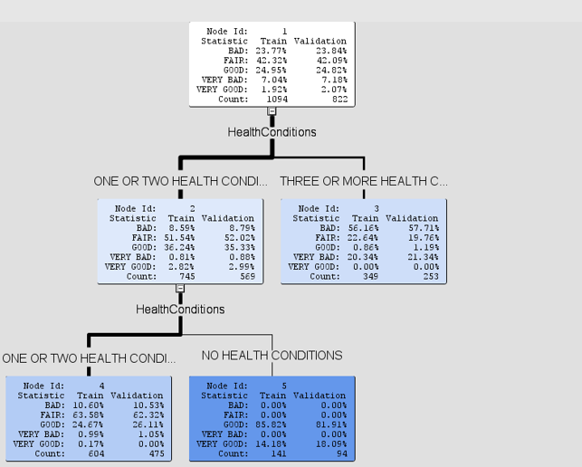
This decision tree indicates that a total of 5 nodes were produced from the of self-reported general health data. The first branch comprising of the self-reported general health status branched out to two categories of patients or respondents with one of more health conditions and three or more health conditions. The category of one or two health condition has more categories comprising of people with one or health conditions as well as no health conditions. There were 141 people of no health conditions and they mainly reported having food (85.82%) and very good health. The group which is most at risk comprises of those with three or more health conditions who reported having bad (56%) and fair (22.63%) health statuses.

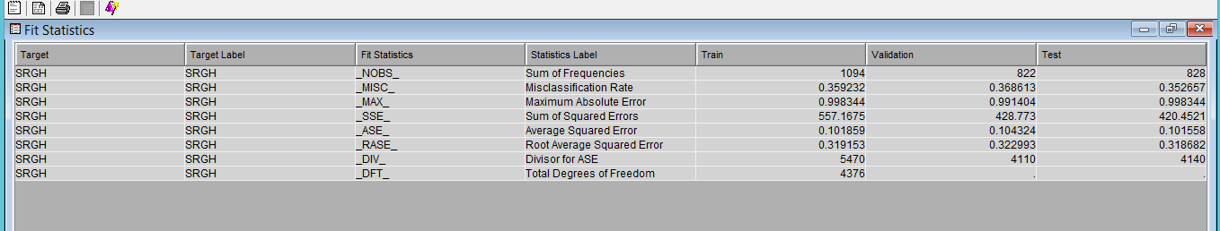

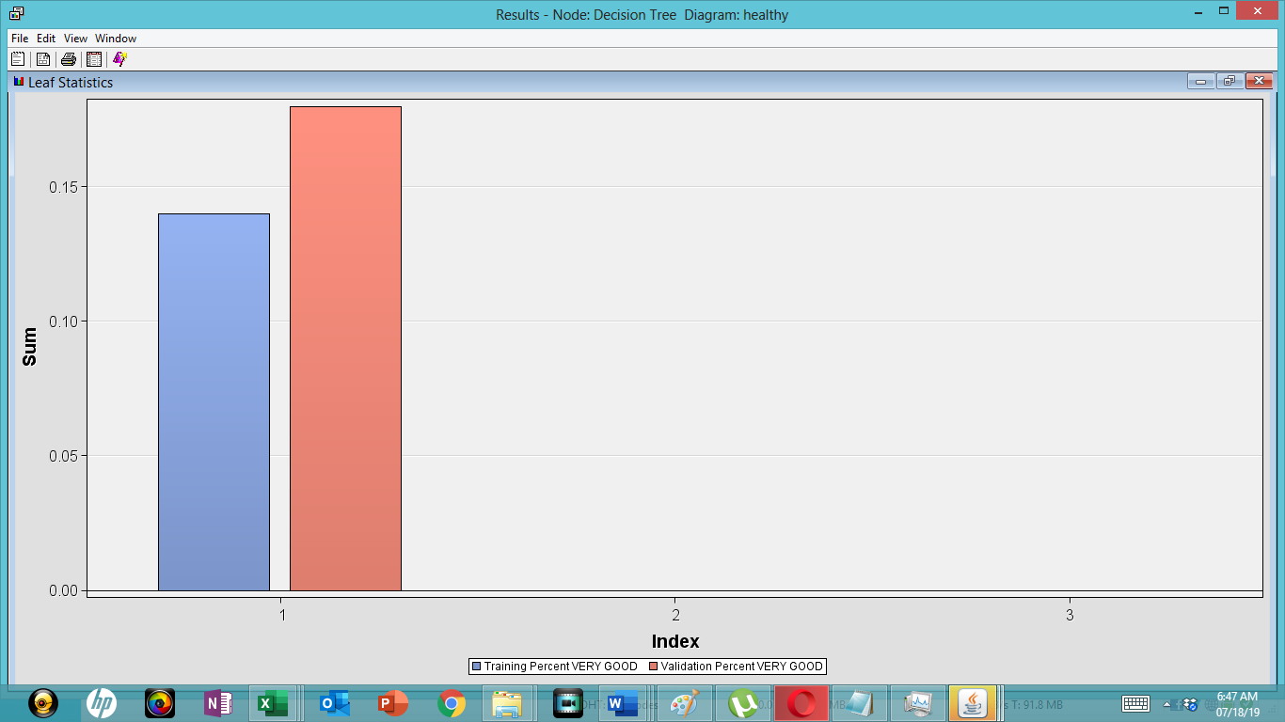

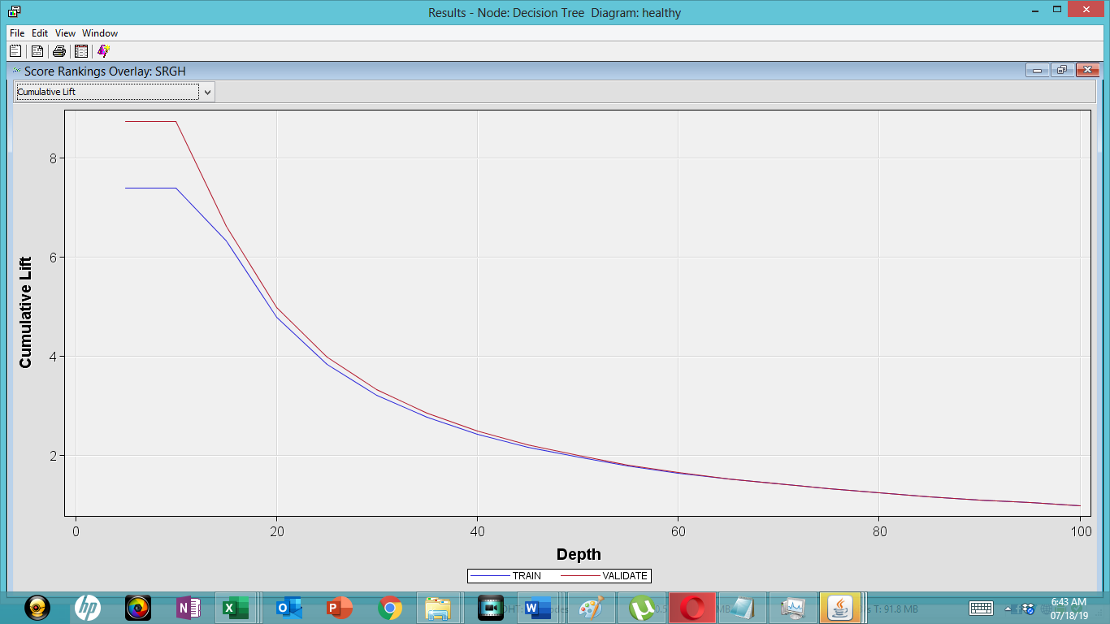

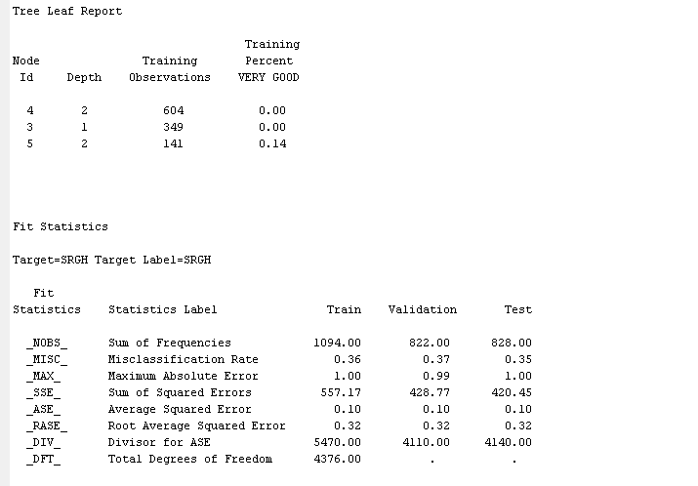
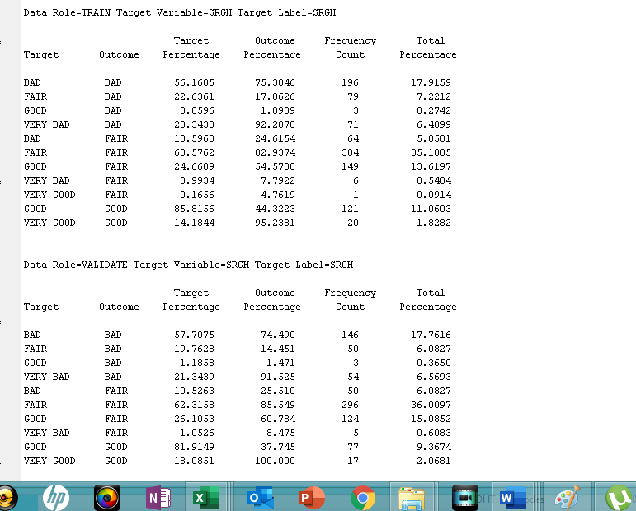
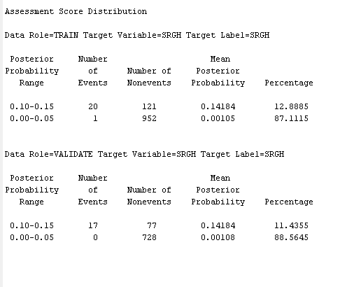
Assessment and reflection
The assessment of the outcome sis the final stage in the data mining process and it yielded the following information.
Overall sampling and recommendation
The sampling method used was adequate since it used adequate training and validation samples. ‘
Clinical recommendation/recommendation to healthcare
The information gathered from the self-reported general health analysis should be used to plan population health initiatives. Patient with three or more health conditions must be monitored and placed under proper clinical care.
Model advantages and disadvantages
The main advantages if the decision tree model are as follows;
- Easier to understand
- Has high value even when exposed to little hard data
- Can help in the determination of the best, moderate and best scenarios
- Can be incorporated into other decision models
Deployment
The model can be deployed within a short time (under 48 hrs.) using limited human resources
Values
The use of such a model can save the healthcare industry millions of dollars in population health planning and improve the healthcare outcomes of people under different health categorizations.

References
Ahmed, S., Berzon, R. A., Revicki, D. A., Lenderking, W. R., Moinpour, C. M., Basch, E., ... & Wu, A. W. (2012). The use of patient-reported outcomes (PRO) within comparative effectiveness research: implications for clinical practice and health care policy. Medical care, 1060-1070.
Jepsen R, Dogisso TW, Dysvik E, Andersen JR, Natvig GK. A cross-sectional study of self-reported general health, lifestyle factors, and disease: the Hordaland Health Study. PeerJ. 2014;2:e609. Published 2014 Oct 2. doi:10.7717/peerj.609

